Stage 1 – Design code and Deploy on Virtual Machine

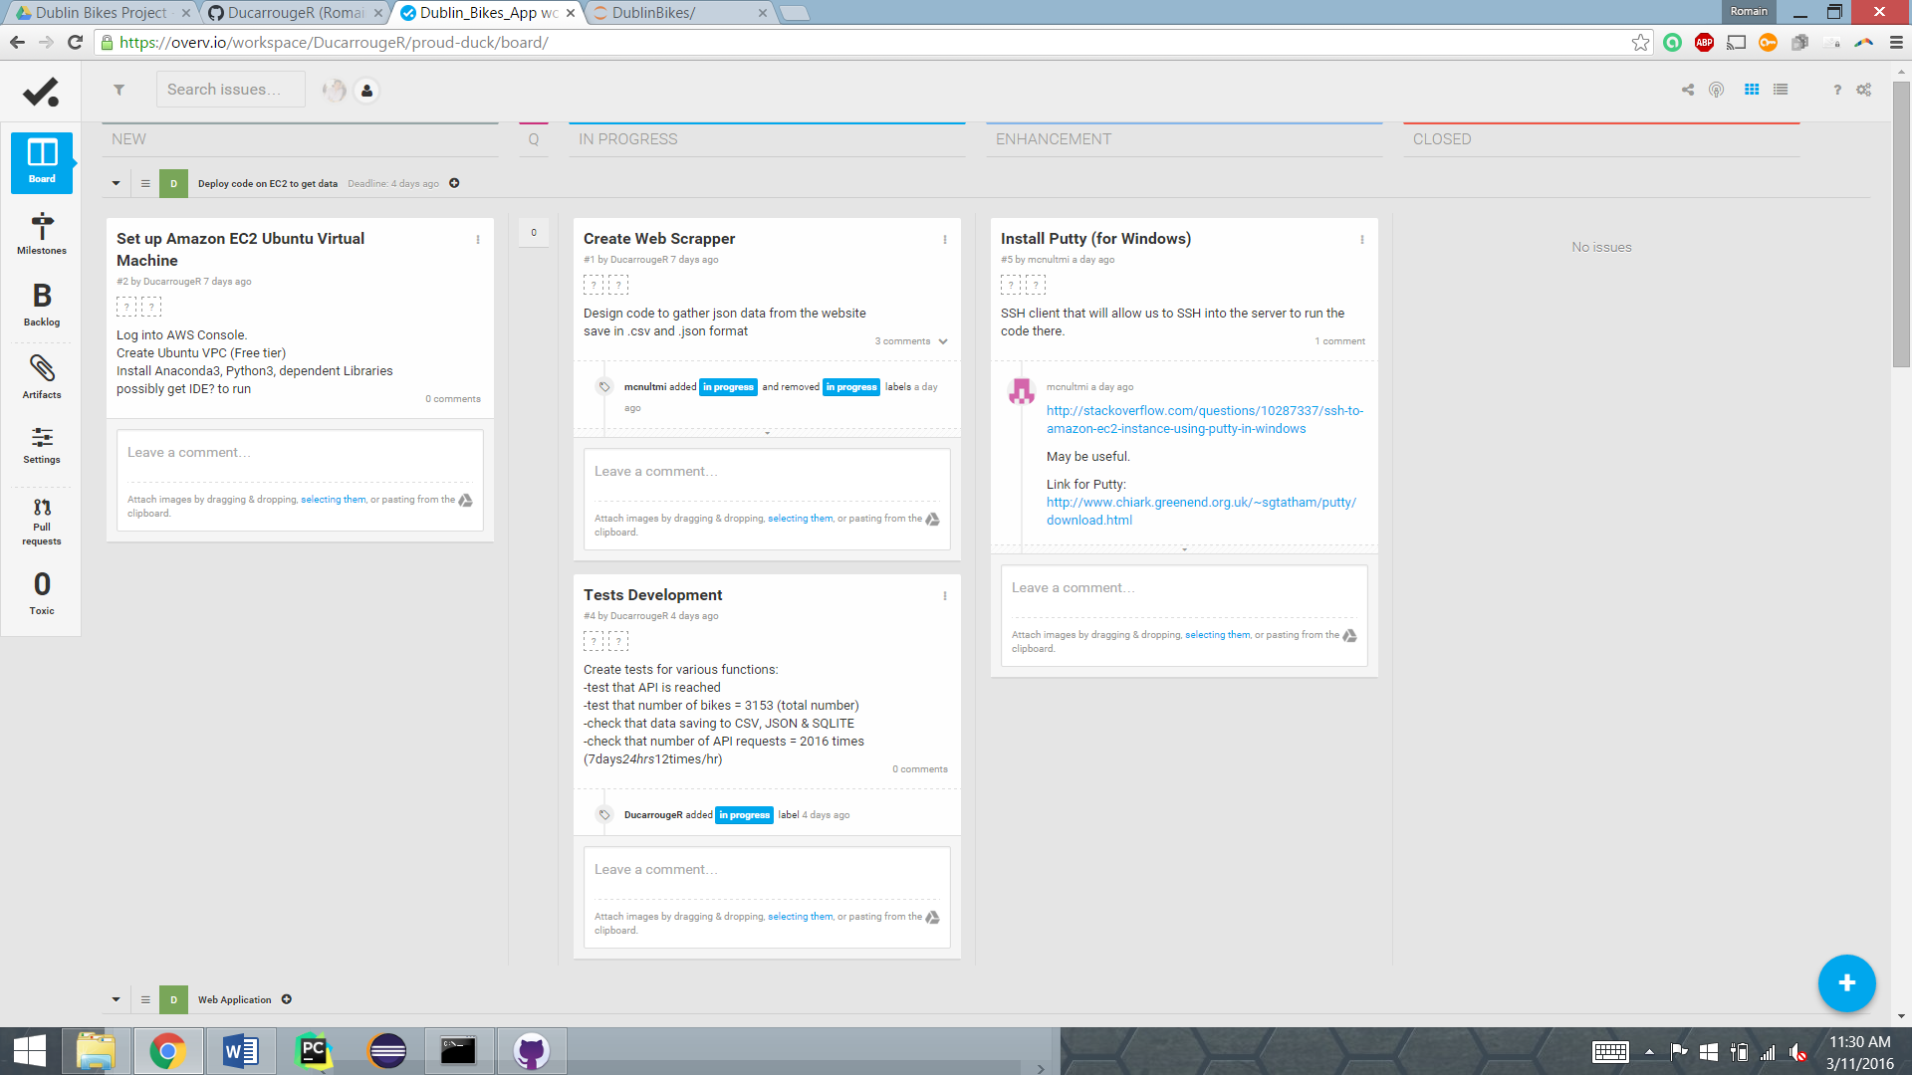

Stage 2 – Design the supporting Web Application

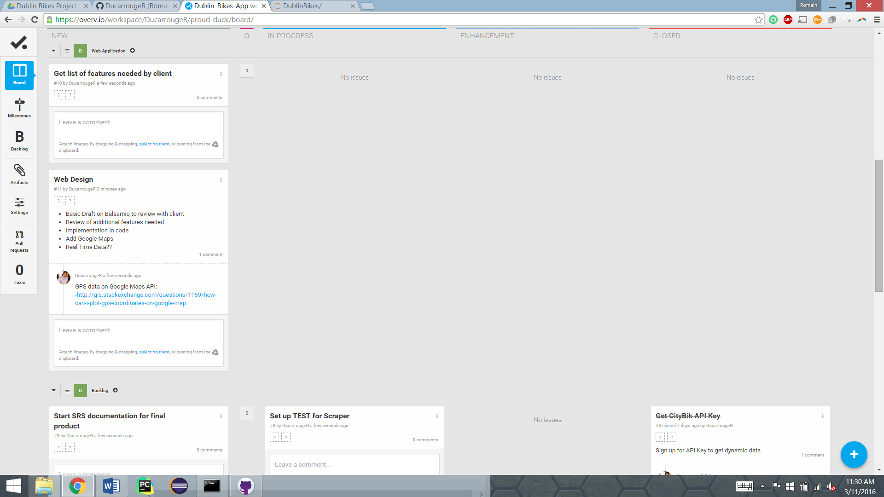

Process Backlog -

